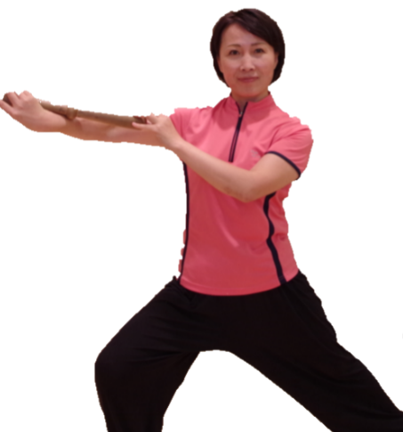
Millennium Taiji Qigong Lesson
Date - March 15,2015
Time 12: 00- 2:00 pm
Location I-building court yard
The Tai Chi Qigong stick has 1000 years of history and was the Emperor's secret to being healthy and robust. It is easy to learn and exercises with the stick include relaxing, thinking, and breathing. Through spiral movements, it can rid the body of toxins and result in significant weight loss, strong internal organs, and better blood circulation. The Taiji Qigong stick can also help with fitness, beauty, and self-balance. In addition, doing exercises with the Taiji Qigong stick can reduce risk of chronic diseases as well as promote long term health.
Who is the instructor?
Lin Jie
Chairman of the NPO Japan Cultural Exchange Center
Chen Style Taijiquan is 19th generation descendant of the second-generation Master Feng Zhiqiang Direct entry disciple, Hun Yuan Chen Style Taijiquan founder mind
Director of the Beijing Institute of sub-health. Young Japanese exchange center as Tai Chi instructor.
1995 began in Okinawa and Tokyo popularity Taiji Qigong stick, the existing 1,000 members.
There are thousands of years of history professor fitness Qigong Tai Chi stick for many years, experienced.
Won several individual and collective national championship.
2012 was the fourth of the World Association of Natural Medicine "Tai Chi stick paper" award.
What students need to bring?
Small rolling pin, flour stick or a rolled-up magazine
Fee: $ 10

教授千年奇功太极棒
日期 - 三月15，2015
时间12:00-下午2:00
位置I-building court yard。

太极棒气功有1000年的历史，曾是宫廷里秘传给皇帝的养生功法,强身健体,延年益寿. 它的特点是容易学, 通过放松，意念，和呼吸来做螺旋运动，达到内外兼修的效果。
通过螺旋运动可以排除体内毒素，达到吐故纳新有明显的减肥作用。并强壮五脏六腑，促进血液循环！达到健身美容的效果，提高精，气，神, 达到阴阳平 衡. 对于预防和治疗慢性病有明显的效果。长期坚持就能够获得健康和健美！

谁是主持人？
讲师：林杰
NPO法人日中文化交流中心理事长
陈式太极拳第19代传人，冯志强大师第二代直传入门弟子，陈式心意混元太极拳创始人
北京亚健康研究所主任。日中青年交流中心等担任太极讲师。
1995年开始在日本冲绳和东京普及太极棒气功，现有会员1000人。
教授有千年历史的健身奇功太极棒多年，经验丰富。
曾多次获得个人和集体全国冠军。
2012年获得第四届世界自然医学学会“太极棒论文”奖。

学员需要带什么?
小擀面杖,面棒或一个卷起的杂志

收费: $10

